

Project Management Plan

Global Fish Tracking System



| FOR | ESA and Starion |
| --- | --- |
| BY | Development Seed |
|  |  |
| VERSION | 1.0 |
| DATE | March 10, 2024 |



## Introduction

This Project Management Plan serves as a comprehensive guide for achieving a successful execution of the Global Fish Tracking System (GFTS) project. It outlines the strategic objectives, scope, and organizational structure necessary to achieve project success. This plan provides a roadmap for stakeholders to collaborate effectively and navigate through the project lifecycle.

Throughout this document, aspects such as team organization, project scheduling, project documentation, code publishing strategy, and communication strategies are delineated. These components are designed to foster proactive agile decision-making and mitigating potential obstacles that may arise during project implementation.

During the implementation of this project, we'll employ a co-creation approach to ensure transparency in decision-making, documentation, and communication, fostering trust among stakeholders and empowering informed participation. By embracing these principles, we aim to not only deliver a cutting-edge GFTS platform but also contribute to the advancement of knowledge, technology, and sustainability in biologging science and marine species conservation.

## Organization

This section describes the project team and how we will communicate and organize our work.

### Project team

Our project team consists of three entities with a common ground but complementary focus areas. Each participant will focus on a separate area of expertise throughout the project. The first is focused on scientific modeling, the second is focused on infrastructure deployment and management, and the third is focused on public facing interface design.

Institut Francais Recherche pour l’Exploitation de la MER (IFREMER) is an industrial and commercial public body. It operates under the joint auspices of the Ministry of National Education, Research and Technology, the Ministry of Agriculture and Fisheries and the Ministry of Equipment, Transport and Housing. Being involved in all the marine science and technology fields, IFREMER has the capability of solving different problems with an integrated approach.

IFREMER scope of actions can be divided into four main areas: understanding, assessing, developing and managing the ocean resources; improving knowledge, protection and restoration methods for marine environment; production and management of equipment of national interest; helping the socio-economic development of the maritime world. Their research is grounded in sustainable development and open science. IFREMER has more than 1,5000 personnel that are spread throughout France. IFREMER is the representative of the users of the tool proposed in this activity.

Simula Research Laboratory (SRL) is a Norwegian research institute. They are organized as a private company but are owned and funded by the Norwegian government. Their main objective is to create knowledge about fundamental scientific challenges that are of genuine value for society. They are deeply involved in the Pangeo ecosystem that will be a cornerstone of this use case.

Development Seed (DS) is a Portuguese small business that builds geospatial products with open source software and open data to empower our partners to track and understand a changing planet. It is part of a global group, headquartered in Washington DC and established in 2003. Development Seed has 56 employees, consisting of cloud engineers, product developers and designers, and AI/ML engineers. Development Seed is trusted by organizations like NASA, Microsoft, AWS, the Red Cross and the World Bank to build out their geospatial data infrastructure and products.

IFREMER is the end user of the proposed decision support tool. In this role, they will provide the end-user perspective throughout the whole project to ensure that the end product fits the relevant user needs. IFREMER is also the scientific partner that will be responsible for the data and modeling. SRL will be building the infrastructure to support the modeling behind the decision support tool. Based on the infrastructure and the modeling, Development Seed will be responsible to build an interface that will allow exploring the model output and run what-if scenarios.

### Communication

In this project we will keep the line of communications short and direct. This will help the agile framework approach to development that we will adopt throughout the project. The consortium leader will be the main interface with Starion and ESA representatives throughout the project. Within the consortium, communication will happen directly between the doers of the different parts based on demand. We will hold regular sprint review meetings to update each other on progress and blockers so that we can work efficiently. This will help to identify and solve challenges as early as possible.

In case of disagreement, we will hold a disagreement meeting where we try to find a solution that everyone can work with. The idea of this is a “disagree and commit” management principle. We will try to find a way forward that is workable for all participants. In case this fails, the consortium leader will have the last words on the decisions.

The project manager is Daniel Wiesmann from Development Seed. The Work Package (WP) leaders are responsible for the achievement of the respective goals identified within each WP, the exchange of products and results with other work packages, the communication within their WP and with the Project Manager. Project meetings will be held on a regular basis, by means of video conferences or in person to ensure a coherent, consistent and efficient execution of all project tasks. Potential problems can be identified and solutions can be found at the respective level, like the overall project level or the work package level.

Meetings as well as the regular progress reports will help to supervise the work progress and compare it to the respective project targets, the timely execution of the tasks, and the quality of the deliverables. The described measures help to ensure that the project remains within schedule, within budget, and achieves its objectives.

All deliverables will be compiled by the respective WP leaders and submitted for quality control to the project manager one week before the delivery date. The project manager will review the deliverable and iterate with the WP leader if required. All deliverables will be submitted by the project scientific and management lead, Daniel Wiesmann.

The following graphic illustrates the agile project organization that we will use for our consortium.

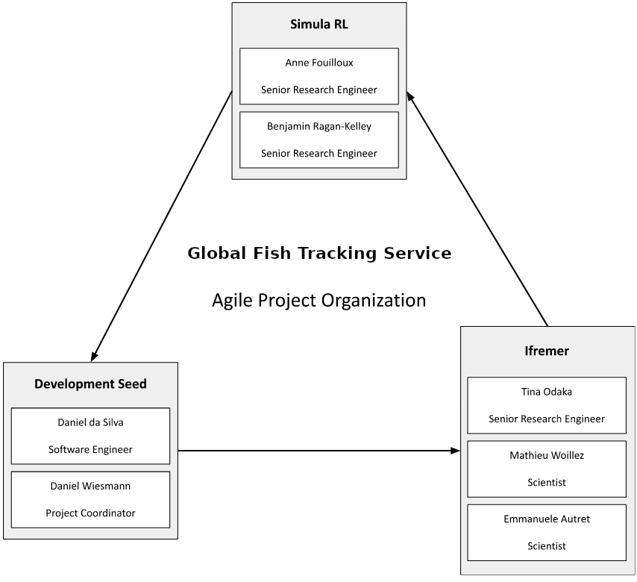

### Project Roles

The table below summarizes the position of each team member in his or her own organization. All the team members are very experienced and distinguished scientists or engineers in their field of expertise. The table below also summarizes the role(s) and average time dedicated to the project by the key personnel.

We will have several key types of roles within the consortium.

* End user role, providing input to the agile development process ensuring final product addresses key user needs
* Infrastructure engineering role, responsible for design and implementation of the system architecture on the backend
* Scientific role holding the knowledge for the modeling and responsible for implementation of the fish movement modeling in the platform
* Interface design and development role, responsible for the implementation of the interactive interface for the decision support tool. This includes a product owner perspective.

### Code and documentation

We will use GitHub for coordination of the software development throughout our use case. Following our principles of open scientific collaboration and transparency, we are working on a fully open repository from the beginning. The repository can be accessed through the following url

<https://github.com/destination-earth/DestinE_ESA_GFTS>

In the same repository we will also publish all the documentation of the use case, including the Use Case Descriptor document. We will base our documentation on the [JupyterBook](https://jupyterbook.org/) library and produce a rendered version of the documentation through GitHub pages under the following url

[https://destination-earth.github.io/DestinE_ESA_GFTS](https://destination-earth.github.io/DestinE_ESA_GFTS/)

This documentation website will be continuously updated throughout the duration of our use case project.

## Planning

This section describes the schedule of the study. The duration of the work of this study will be 12 months. We will start the project with a formal internal Kick-Off (KO) meeting, after which we will start the agile development process.

We will organize development in two week sprints and will hold regular sprint review meetings. This will ensure that we track progress and that our solution emerges through collaboration, continual planning and learning, and in line with our plan to release tightly integrated high-quality software throughout the project. While we are going to apply lean and agile development principles, we foresee four major technical milestones that will be reviewed in collaboration with Starion. Below is the table listing these major technical Milestones.

| Milestone (MS) Name | Schedule Date | Description |
| --- | --- | --- |
| MS1: Release Review 1 (RR1) | KO + 3 months | First Use Case release |
| MS2: Release Review 2 (RR2) | K0 + 6 months | Second Use Case release |
| MS3: Release Review 3 (RR3) | K0 + 9 months | Third Use Case release |
| MS4: Final Review (FR) | K0 + 12 months | Final Use Case release |

### Work breakdown

The main results and outputs from the project will be:

* Final Report document summarizing the implementation of this project
* One or more GitHub repositories containing all the source code developed under this project, released under a major open source license such as the GNU public license.
* An functional version of the developed decision support system, fully deployed to the DestinE Platform platform
* Documentation of the decision support tool and all the source code

Our work programme is organized under 4 main tasks that are tightly aligned with the ones given in the SoW. The four main tasks and their corresponding work packages are

* Task 1: Project Management, WP1
* Task 2: Agile Use Case Development and Demonstration, WP2
* Task 3: Use Case Promotion, WP3
* Task 4: Use Case Exploitation, WP4

The tasks are bundled under their corresponding work package as indicated above.

#### GANTT chart

In the GANTT chart below, the months are abbreviated to M, i.e. M5 represents Month 5.

| ID | Key Task | M1 | M2 | M3 | M4 | M5 | M6 | M7 | M8 | M9 | M10 | M11 | M12 |
| --- | --- | --- | --- | --- | --- | --- | --- | --- | --- | --- | --- | --- | --- |
| WP1 | Project Management |  |  |  |  |  |  |  |  |  |  |  |  |
| WP2 | Agile Use Case Development and Demonstration |  |  |  |  |  |  |  |  |  |  |  |  |
| WP3 | Use case promotion |  |  |  |  |  |  |  |  |  |  |  |  |
| WP4 | Use case exploitation |  |  |  |  |  |  |  |  |  |  |  |  |

### Meeting schedule

We will have a close and up to date communication with our point of contact at Starion. We will schedule and organize monthly progress meetings with the Starion representatives and contribute to monthly reports. In addition, we will take part in the following reviews to create opportunities to have a more in-depth review of the status of the use case and progress made.

| Review name | Date | Comment |
| --- | --- | --- |
| RR1 Release Review 1 | K0 + 3 | As proposed in the SoW V1.0 Final document, no changes suggested. |
| RR2 Release Review 2 | K0 + 6 | As proposed in the SoW V1.0 Final document, no changes suggested. |
| RR3 Release Review 3 | K0 + 9 | As proposed in the SoW V1.0 Final document, no changes suggested. |
| FR Final Review | K0 + 12 | As proposed in the SoW V1.0 Final document, no changes suggested. |